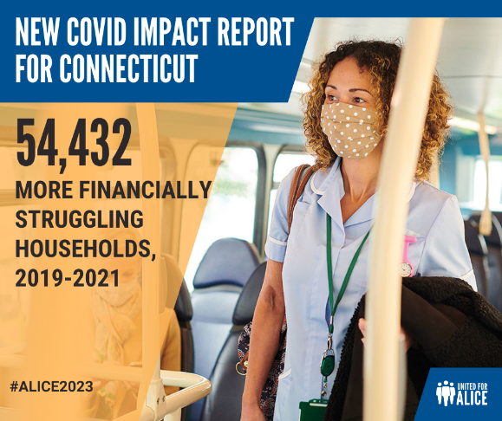
Economic forces such as job disruption, inflation, wage increases, pandemic assistance, and migration worked with and against each other throughout the pandemic. The result: From 2019 through 2021, CT saw an increase in the total number of households in poverty and ALICE households – earning above the Federal Poverty Level but not nearly enough to afford basics – from 498,278 to 552,710 – that’s an 11% increase! #ALICE2023 #economy #poverty #hardship #workingpoor
TO LOCALIZE FOR YOUR REGION: COPY FIRST, THEN EDIT THIS CANVA LINK: https://www.canva.com/design/DAFsUZTKpYA/ZXmhjd7zKGkowVv_xWlX_w/edit?utm_content=DAFsUZTKpYA&utm_campaign=designshare&utm_medium=link2&utm_source=sharebutton

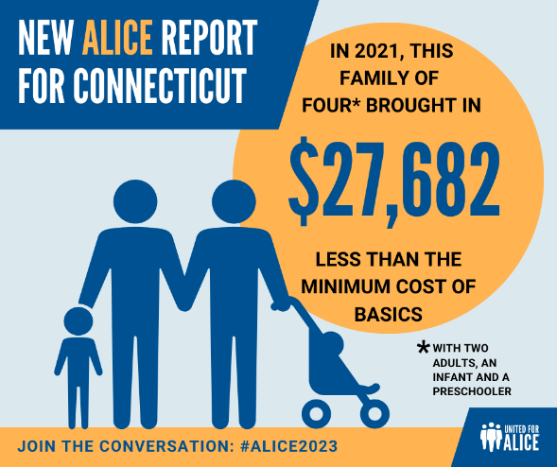
Tax credits and other pandemic supports – for which nearly all ALICE households were eligible yet only 45% received – mitigated the pandemic’s negative financial impacts. Yet even with these temporary supports, many ALICE households did not reach financial stability.
In 2021, for a family with two kids and two adults in CT, the Household Survival Budget – which calculates the minimum needed to afford necessities, before inflation, tax credits and pandemic supports – was $91,428. With two full-time workers in two of CT’s most common jobs, and multiple pandemic supports, that family's income still fell short of the Budget by $27,682, or 35%! #ALICE2023 #economy #poverty #hardship #workingpoor
TO LOCALIZE FOR YOUR REGION: COPY FIRST, THEN EDIT THIS CANVA LINK: https://www.canva.com/design/DAFsUVToCUU/dzzET88SZBycLVCIhRowXQ/edit?utm_content=DAFsUVToCUU&utm_campaign=designshare&utm_medium=link2&utm_source=sharebutton

Join us in Hartford on Tuesday as we share with you this year’s Connecticut ALICE Report, ALICE in the Crosscurrents. Who is ALICE? ALICE is us, our friends, neighbors, coworkers and family members. We lean on ALICE for support; yet many ALICE households are one emergency away from a financial crisis impacting their ability to feed their family, heat their home, maintain their house and ensure their medical care. For a growing number of U.S. households, financial stability is nothing more than a pipe dream, no matter how hard they work.
This event offers an important opportunity to hear from CT families and understand who is struggling, why and the specific ways COVID-19 has impacted our economy. #ALICE2023 #economy #poverty #hardship #workingpoor

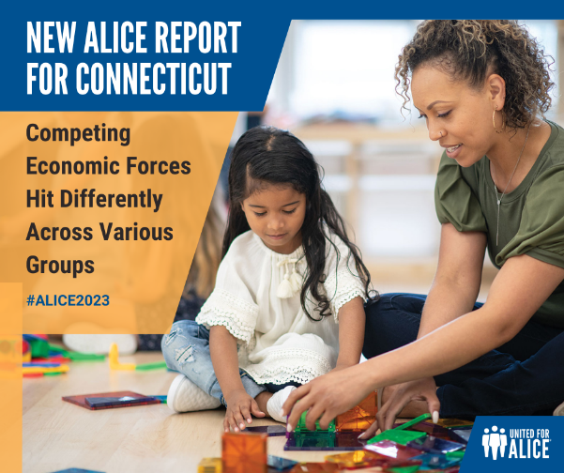
Throughout the pandemic, the impact of competing forces played out differently across demographic groups. In many cases, the pandemic exposed and widened gaps in rates of hardship by race/ethnicity, age, and household composition. In CT in 2021, Black, Hispanic and biracial households were more likely to be ALICE or in poverty, while White and Asian households were more likely to be financially stable. #ALICE2023 #economy #poverty #hardship #workingpoor

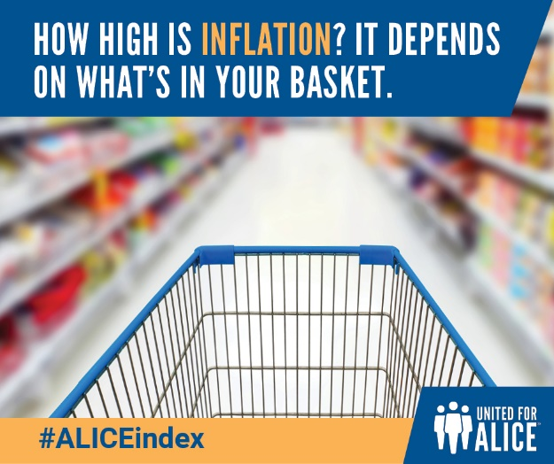
Inflation persists across CT and nationwide, with the #ConsumerPriceIndex (#CPI) at the center of each discussion. Yet the CPI conceals what has become a devastating reality for many lower income households, including ALICE (Asset Limited, Income Constrained, Employed) and those in poverty.
The statewide ALICE Essentials Index, which tracks only the basics that families need to survive over time shows an increase overall statewide household survival budget for a family of four with two young children to more than $126,000. #ALICEindex #UnitedForALICE #ALICE2023
Discover a more accurate measure of #inflation for families that can’t make ends meet: United4ALICE.org/ALICEindex #economy #risingcosts #costofliving #costofgoods #priceincrease #workingpoor #poverty

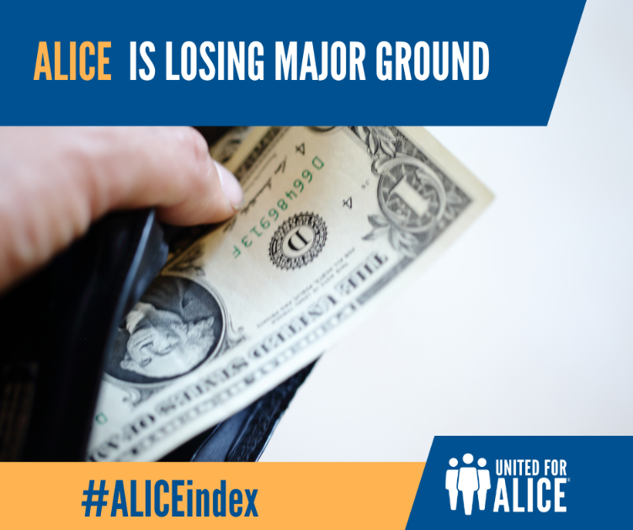
As the costs of basics have climbed, wages for ALICE workers have failed to keep up. The result? Workers have lost buying power over the past 15 years. For a retail salesperson in CT, that loss equates to nearly $42,500 — more than a full year’s earnings. #ALICEindex #CPI #ConsumerPriceIndex #UnitedForALICE #ALICE2023 #economy #risingcosts #costofliving #costofgoods #priceincrease #workingpoor #poverty
Learn more about the ALICE Essentials Index, which shows how #inflation has truly impacted households that can’t make ends meet: United4ALICE.org/ALICEindex

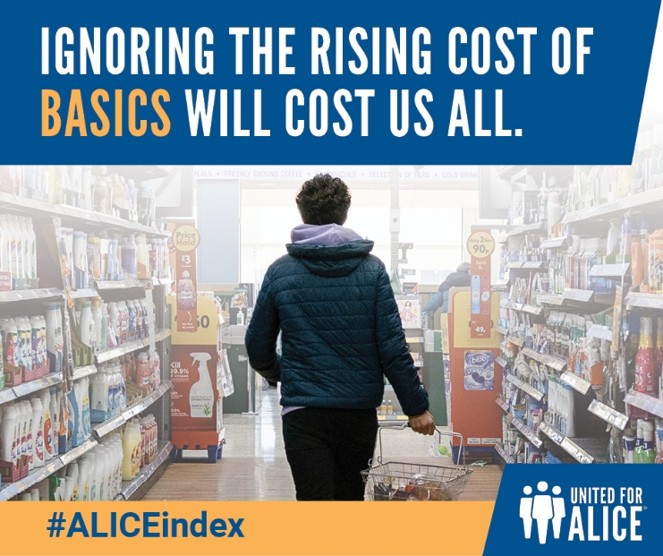
The #ConsumerPriceIndex (#CPI) is used to calculate increases for many public benefits in CT. But since it doesn’t keep up with the cost of household basics, those benefits purchase less each year. This is especially true for programs that matter most to ALICE, including:
Social Security
Veterans’ pensions
SNAP
Medicaid
ALICE workers are the engine that keeps our economy running. We all know and need ALICE — so when ALICE can’t pay the bills, we all pay the price.
Learn more about the ALICE Essentials Index, a more accurate measure of #inflation for households in hardship: United4ALICE.org/ALICEindex #ALICEindex #UnitedForALICE #ALICE2023 #risingcosts #costofliving #costofgoods #priceincrease #workingpoor #poverty

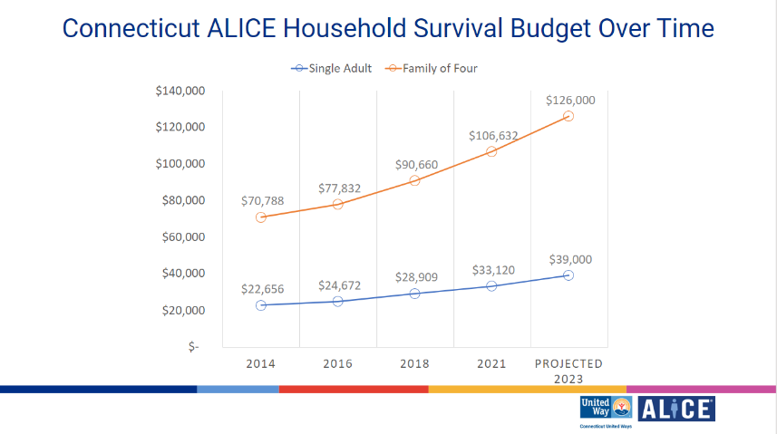
The historic levels of inflation in the last few years, which has increased at a higher rate for household essentials (the backbone of the Household Survival Budget), puts financial stability further out of reach for CT households.​ #ALICE2023 #risingcosts #costofliving #costofgoods #priceincrease #workingpoor #poverty

​

