Please customize this sample to tell your story. If you have any questions or ideas, contact Daniel.Fitzmaurice@CTUnitedWay.org anytime. Thanks for your time and support!

Public Hearing Testimony before the Connecticut General Assembly’s
Finance, Revenue, and Bonding Committee
March 6, 2024

In Support Of “S.B. 36 An Act Establishing A Refundable Child Tax Credit” and “H.B. 5113 An Act Increasing The Highest Marginal Rate Of The Personal Income Tax And Establishing A Capital Gains Surcharge To Provide Funding For Certain Child-related, Municipal And Higher Education Initiatives”

Dear Senator Fonfara, Representative Horn, Senator Martin, Representative Cheeseman, and members of the Finance, Revenue and Bonding Committee:

Thank you for the opportunity to testify in support of creating a Connecticut Child Tax Credit. While revenues are stronger than ever at the capitol, more than half a million families struggle to make ends meet across every community in our state. The latest ALICE Essentials Index (figure 1) found that a family with two adults and two young children needs to work full-time at $63/hour to afford living here – an increase of 18% since 2021.

That’s why I strongly support S.B. 36 and H.B. 5113. Both provide households with children a fully refundable credit of $600 per child. (figure 2). Statewide, this will reach 75% of our families and up to 550,000 of our children.

According to a recent public opinion poll, 73% of voters in Connecticut, regardless of whether they are raising children, also support this policy. It’s easy to see why:
- We live in one of the most expensive places to raise a child at $16,990 per year
- It’s proven – the federal Child Tax Credit lifted 33,000 children in our state out of poverty in 2021
- For each $1 a family earns from a Child Tax Credit, they return $1.38 to their local economy
- We are the only state that taxes a family's income but does not offer a tax policy that offsets the costs of raising children (figure 2)
I also want to underscore the importance of a Child Tax Credit that is fully refundable. This is the only way to provide this support for our lowest income families, a population in which parents of color are disproportionately represented (figure 3). Research shows that the flexibility of a Child Tax Credit allows families to meet their most urgent basic needs, from stocking the pantry to paying an overdue utility bill.
Where I live/work in location, this hardship is real. Insert a story about how you or ALICE families you know struggle to get by and/or how a Connecticut Child Tax Credit would make a difference.
This is a perfect storm for families who are working hard to get by. Connecticut is in a financial position to help. Pass a fully refundable Connecticut Child Tax Credit of $600 per child this session to ensure that our families, the center of our community and workforce, can begin to thrive.

Sincerely,
Your Name
Organization (if applicable)
Location where you live or work

Figure 1
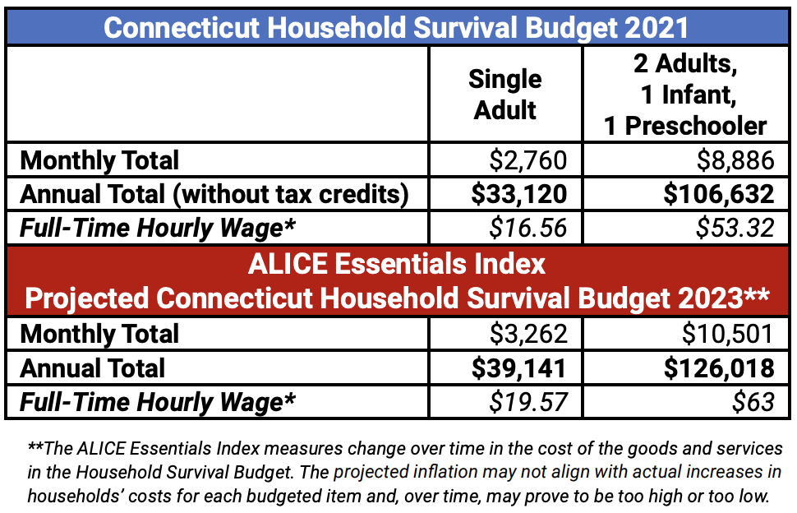
Connecticut United Ways, ALICE in the Crosscurrents, 2023

Figure 2
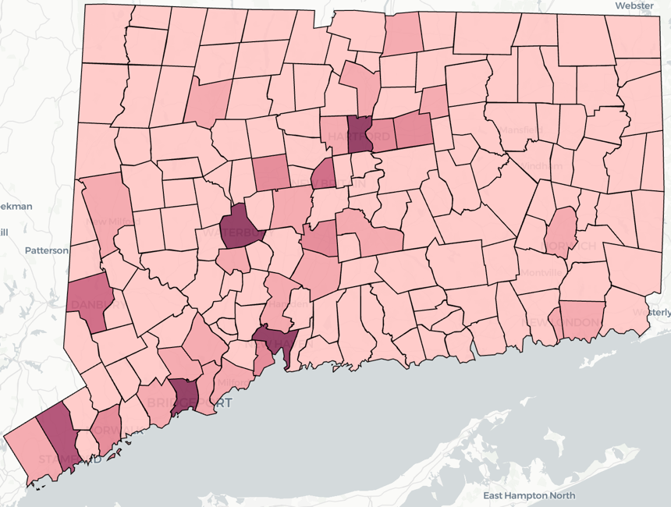
DataHaven, The proposed Connecticut Child Tax Credit: Estimating impacts for towns, legislative districts, and households by race and ethnicity, 2024

Figure 3
State Personal Income Taxes (PIT) that Adjust for the Cost of Children
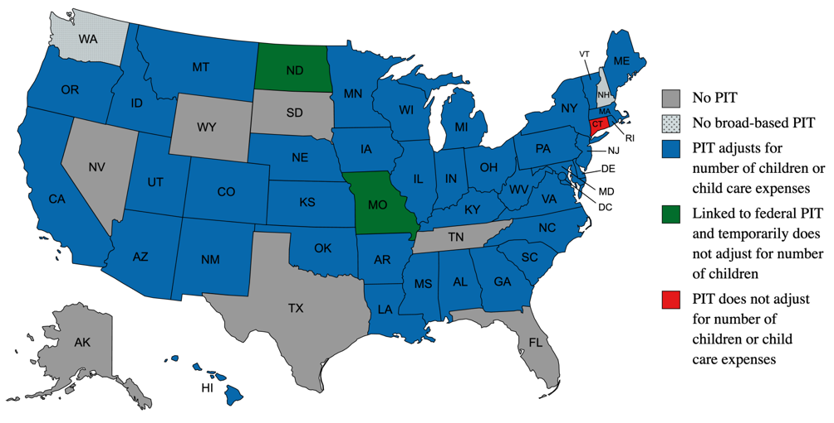
CT Voices for Children, Supporting The Economic Well-being Of Connecticut's Families And Children, 2024

Figure 4
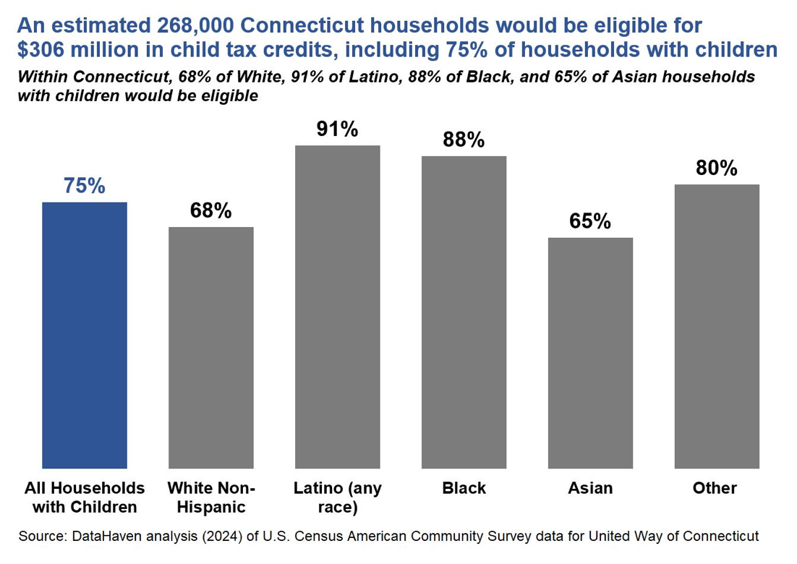
DataHaven, The proposed Connecticut Child Tax Credit: Estimating impacts for towns, legislative districts, and households by race and ethnicity, 2024

