CT Child Tax Credit Social Media Toolkit

In this document you will find ten sample social media posts for you to customize to your needs. Whenever posting to social, please be sure to:

- Tag:

- Your personal legislators on your personal platforms
- Our state contingency on your institutional platforms: @Office of Governor Ned Lamont, @Connecticut Senate Republican Caucus, @CT Senate Democrats, @Connecticut House Democrats, @Connecticut House Republicans
- Include:

Call to Action: Contact Your Legislators NOW
URL: https://alice.ctunitedway.org/ct-ctc/

- YouTube Video: https://youtu.be/VlaUNQaVAdc?si=c0NoyLGq2NiD8ZWl

The hard truth is that more than 550,000 households cannot afford the cost of living in CT, yet we live in one of the wealthiest states in the country.

Contact your legislators now and ask them to pass a permanent and fully refundable CT Child Tax Credit this legislative session – our lowest income households especially deserve flexible income to meet their most pressing needs: https://alice.ctunitedway.org/ct-ctc/

@Office of Governor Ned Lamont, @Connecticut Senate Republican Caucus, @CT Senate Democrats, @Connecticut House Democrats, @Connecticut House Republicans

2.
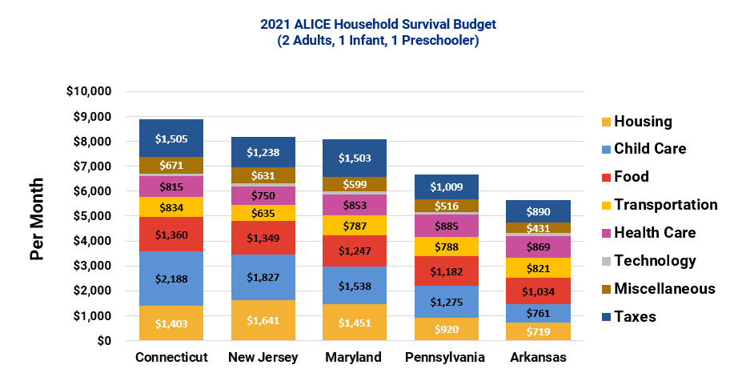

Compared to other states, CT has a high cost of living, families are struggling and receive a limited amount of government support. Childcare in particular is very expensive - $16,990 per year per child! Some families have to choose between working or taking care of their children. If they're able to earn at least some extra money back on taxes with a Child Tax Credit, it can help go towards critical necessities for their families.

Contact your legislators now and ask them to pass a permanent and fully refundable CT Child Tax Credit this legislative session: https://alice.ctunitedway.org/ct-ctc/

@Office of Governor Ned Lamont, @Connecticut Senate Republican Caucus, @CT Senate Democrats, @Connecticut House Democrats, @Connecticut House Republicans

3.

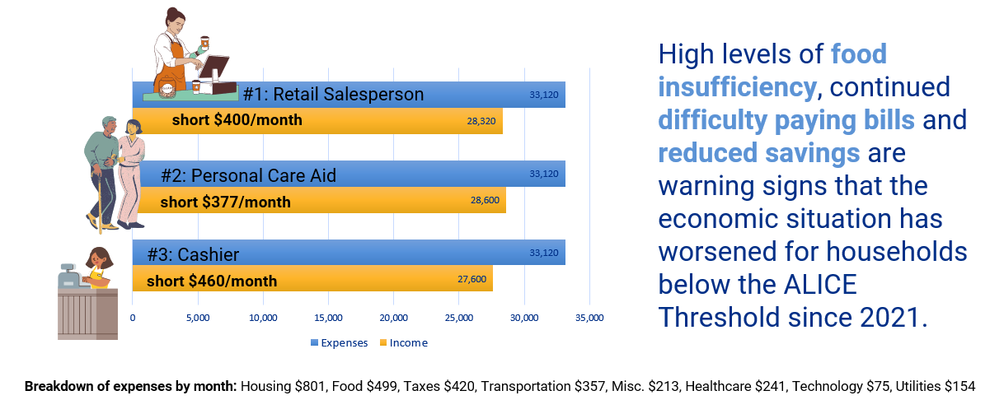

In CT there's a mismatch between wages and the cost of basics. Families are being crushed by inflation and the crushing cost of household essentials and always falling short of what they need.

The Child Tax Credit would help families live better lives, spend money on necessities and local businesses and allow our state economy to grow.

Contact your legislators now and ask them to pass a permanent and fully refundable CT Child Tax Credit this legislative session: https://alice.ctunitedway.org/ct-ctc/

@Office of Governor Ned Lamont, @Connecticut Senate Republican Caucus, @CT Senate Democrats, @Connecticut House Democrats, @Connecticut House Republicans

4.

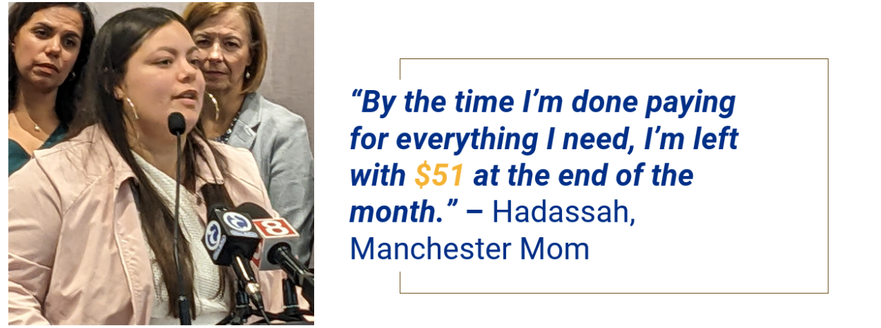

A permanent, refundable state Child Tax Credit of $600/child would provide dependable, flexible income to approximately 250,000 households and 350,000+ children, like Hadassah's.

Contact your legislators now and ask them to pass a permanent and fully refundable CT Child Tax Credit this legislative session: https://alice.ctunitedway.org/ct-ctc/

@Office of Governor Ned Lamont, @Connecticut Senate Republican Caucus, @CT Senate Democrats, @Connecticut House Democrats, @Connecticut House Republicans

5.
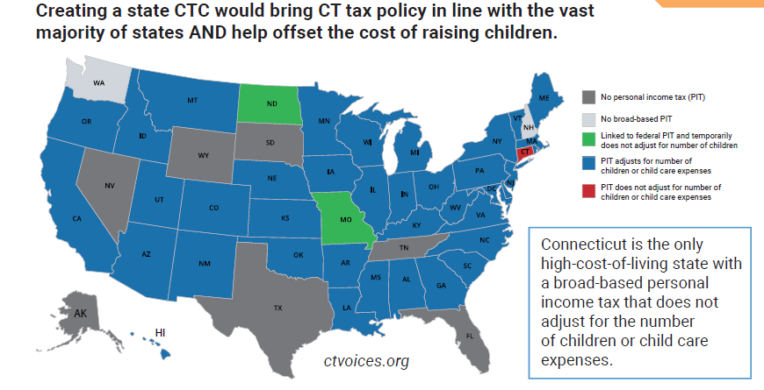
Are you as upset as we are that Connecticut is the ONLY state in the country that has a personal income tax that does NOT adjust for the number of children or child care expenses you have? Working families with children need all of the help they can get… There is no reason that children should suffer when the state of CT is able to provide assistance. Raising our children should be a shared responsibility of everyone in the community, public and private.

Contact your legislators now and ask them to pass a permanent and fully refundable CT Child Tax Credit this legislative session: https://alice.ctunitedway.org/ct-ctc/

@Office of Governor Ned Lamont, @Connecticut Senate Republican Caucus, @CT Senate Democrats, @Connecticut House Democrats, @Connecticut House Republicans

6.

Are you counting on your income tax return this year to help back pay the credit card charges you had to incur for rent, utilities, food, gas and your children’s clothes? CT families are struggling to provide for their children, which puts a burden on the quality of life for both children and their families. A CT Child Tax Credit would provide relief for the cost of basic needs.

Contact your legislators now and ask them to pass a permanent and fully refundable CT Child Tax Credit this legislative session: https://alice.ctunitedway.org/ct-ctc/ or scan the QR code in the photo to tell them how YOU feel about this year’s tax refund.

@Office of Governor Ned Lamont, @Connecticut Senate Republican Caucus, @CT Senate Democrats, @Connecticut House Democrats, @Connecticut House Republicans

7.
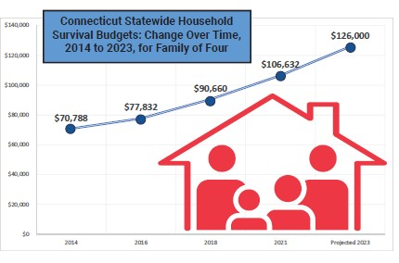
Since 2021, the ALICE Essentials Index shows 18% inflation in the cost of household basics. This means that a family of four, with two working parents, an infant and a toddler need to earn $126,000 per year to make ends meet. Working families with children need all of the help they can get… There is no reason that children should suffer when the state of CT is able to provide assistance.

Contact your legislators now and ask them to pass a permanent and fully refundable CT Child Tax Credit this legislative session: https://alice.ctunitedway.org/ct-ctc

@Office of Governor Ned Lamont, @Connecticut Senate Republican Caucus, @CT Senate Democrats, @Connecticut House Democrats, @Connecticut House Republicans

8.

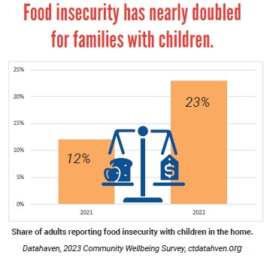
Isn’t it shocking that in a state as wealthy as ours that nearly one quarter of all our families don’t have enough money to put food on the table? We all know that lifting any child or family out of poverty and providing monetary relief for food or childcare makes a parent more productive in society and children more secure.

It’s proven: the federal Child Tax Credit in 2021 lifted 33,000 of our children out of poverty. Let’s provide the same relief and support for Connecticut children.

Contact your legislators now and ask them to pass a permanent and fully refundable CT Child Tax Credit this legislative session: https://alice.ctunitedway.org/ct-ctc/

@Office of Governor Ned Lamont, @Connecticut Senate Republican Caucus, @CT Senate Democrats, @Connecticut House Democrats, @Connecticut House Republicans

9.

Connecticut families, you are not alone. This group of passionate and dedicated organizations is fighting hard to pass a permanent and fully refundable CT Child Tax Credit this legislative session. They know that for each $1 a family earns from the Child Tax Credit, that same family returns $1.38 to their local economy.

It’s a no brainer! Contact your legislators now and ask them to pass a permanent and fully refundable CT Child Tax Credit this legislative session: https://alice.ctunitedway.org/ct-ctc/

@Office of Governor Ned Lamont, @Connecticut Senate Republican Caucus, @CT Senate Democrats, @Connecticut House Democrats, @Connecticut House Republicans

10.

Our rent was due the first of March, but we couldn’t pay it because of our other bills. We have three more rent payments due before the end of this legislative session – that’s $3,333 we’ll be in the hole, if we’re not evicted first. Our family cannot afford to be out on the street. We each work two jobs - how can this be happening?

All children deserve a fighting chance. Give their parents all the resources necessary to help their kids make a better life for themselves.

Contact your legislators now and ask them to pass a permanent and fully refundable CT Child Tax Credit this legislative session: https://alice.ctunitedway.org/ct-ctc/

@Office of Governor Ned Lamont, @Connecticut Senate Republican Caucus, @CT Senate Democrats, @Connecticut House Democrats, @Connecticut House Republicans

11.

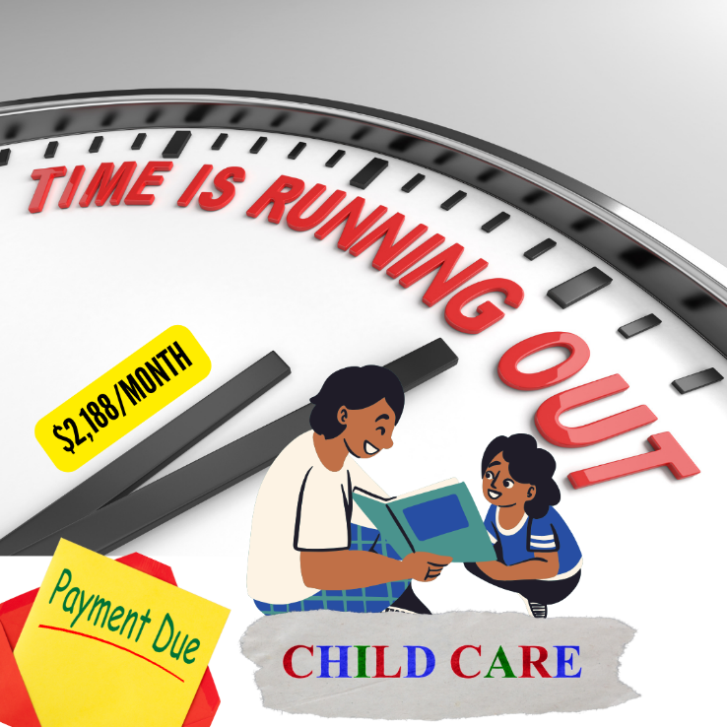

Child care is so expensive. We can’t afford it, but we need it to be able to go to work. It’s a perpetual catch 22. We owe $2,188 is due now for next month, but I just don’t have the money and I don’t know what to do! We each work two jobs just to pay for basic needs - how can this be happening?

All children deserve a fighting chance. Give their parents all the resources necessary to help their kids make a better life for themselves.

Contact your legislators now and ask them to pass a permanent and fully refundable CT Child Tax Credit this legislative session: https://alice.ctunitedway.org/ct-ctc/

@Office of Governor Ned Lamont, @Connecticut Senate Republican Caucus, @CT Senate Democrats, @Connecticut House Democrats, @Connecticut House Republicans

12.

I can’t believe how expensive food has become! Inflation is killing our budget, but we need to be able to put food on the table and feed our children. It’s costing us an average of $1,360 per month to feed our family of four. We can’t afford it and we don’t qualify for food assistance. We each work two jobs just to pay for basics - how can this be happening?

All children deserve a fighting chance. Give their parents all the resources necessary to help their kids make a better life for themselves.

Contact your legislators now and ask them to pass a permanent and fully refundable CT Child Tax Credit this legislative session: https://alice.ctunitedway.org/ct-ctc/

@Office of Governor Ned Lamont, @Connecticut Senate Republican Caucus, @CT Senate Democrats, @Connecticut House Democrats, @Connecticut House Republicans

13.

Thank goodness @Governor Lamont passed a $17 million bill for energy assistance this winter! Utility costs have skyrocketed. Right now, it costs me almost $300 per month for utilities - that bill is a big hit to my budget. We each work two jobs just to pay for basic needs - how can this be happening?
All families deserve a fighting chance. Give them all the resources necessary to help make a better life for themselves and their kids - like dependable, flexible income that allows families to meet their most urgent basic needs, from stocking the pantry to paying an overdue utility bill.

Contact your legislators now and ask them to pass a permanent and fully refundable CT Child Tax Credit this legislative session: https://alice.ctunitedway.org/ct-ctc/

@Office of Governor Ned Lamont, @Connecticut Senate Republican Caucus, @CT Senate Democrats, @Connecticut House Democrats, @Connecticut House Republicans

